Question 1 Output summary report –

Decision Tree Classifier:

iter num : 1 of data split

best parameters : {'max_depth': 16, 'max_features': 32, 'min_impurity_decrease': 0.0001, 'min_samples_split': 4}

confusion matrix :

[[44 0 0 0 2 0 0 0 0 0]

[ 0 36 2 0 1 0 0 1 4 0]

[ 1 0 39 0 0 0 0 1 4 0]

[ 0 0 1 44 1 0 0 0 1 1]

[ 0 1 1 1 36 0 0 0 0 1]

[ 1 0 0 3 0 35 0 1 1 0]

[ 0 1 1 0 0 0 45 0 0 0]

[ 0 1 0 0 4 0 0 41 1 0]

[ 0 3 5 3 0 0 0 0 28 4]

[ 1 2 1 3 0 1 0 2 5 34]]

Accuracy Measure : 0.848888888889

classification report :

precision recall f1-score support

0 0.94 0.96 0.95 46

1 0.82 0.82 0.82 44

2 0.78 0.87 0.82 45

3 0.81 0.92 0.86 48

4 0.82 0.90 0.86 40

5 0.97 0.85 0.91 41

6 1.00 0.96 0.98 47

7 0.89 0.87 0.88 47

8 0.64 0.65 0.64 43

9 0.85 0.69 0.76 49

avg / total 0.85 0.85 0.85 450

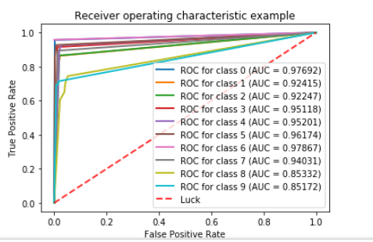

Neural Net Classifier:

iter num : 1 of data split

best parameters : {'activation': 'logistic', 'alpha': 1e-05, 'learning_rate': 'invscaling', 'max_iter': 2000}

confusion matrix :

[[45 0 0 0 1 0 0 0 0 0]

[ 0 42 1 0 0 0 0 0 1 0]

[ 0 0 45 0 0 0 0 0 0 0]

[ 0 0 1 47 0 0 0 0 0 0]

[ 0 0 0 0 39 0 0 0 1 0]

[ 0 0 0 0 0 41 0 0 0 0]

[ 0 1 0 0 0 0 46 0 0 0]

[ 0 0 0 0 0 0 0 47 0 0]

[ 0 2 1 0 0 0 0 0 40 0]

[ 0 0 0 0 0 1 0 0 1 47]]

Accuracy Measure : 0.975555555556

classification report :

precision recall f1-score support

0 1.00 0.98 0.99 46

1 0.93 0.95 0.94 44

2 0.94 1.00 0.97 45

3 1.00 0.98 0.99 48

4 0.97 0.97 0.97 40

5 0.98 1.00 0.99 41

6 1.00 0.98 0.99 47

7 1.00 1.00 1.00 47

8 0.93 0.93 0.93 43

9 1.00 0.96 0.98 49

avg / total 0.98 0.98 0.98 450

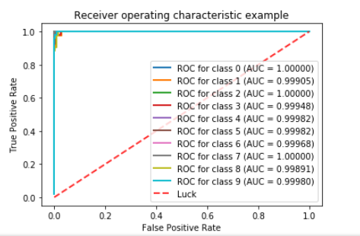

SVM Classifier:

iter num : 1 of data split

best parameters : {'C': 10, 'degree': 1, 'gamma': 0.001, 'kernel': 'rbf', 'max_iter': 1500, 'random_state': 0}

confusion matrix :

[[46 0 0 0 0 0 0 0 0 0]

[ 0 44 0 0 0 0 0 0 0 0]

[ 0 0 45 0 0 0 0 0 0 0]

[ 0 0 1 47 0 0 0 0 0 0]

[ 0 0 0 0 40 0 0 0 0 0]

[ 0 0 0 0 0 40 0 0 0 1]

[ 0 0 0 0 0 0 47 0 0 0]

[ 0 0 0 0 0 0 0 47 0 0]

[ 0 1 0 0 0 0 0 0 42 0]

[ 0 0 0 0 0 1 0 1 0 47]]

Accuracy Measure : 0.988888888889

classification report :

precision recall f1-score support

0 1.00 1.00 1.00 46

1 0.98 1.00 0.99 44

2 0.98 1.00 0.99 45

3 1.00 0.98 0.99 48

4 1.00 1.00 1.00 40

5 0.98 0.98 0.98 41

6 1.00 1.00 1.00 47

7 0.98 1.00 0.99 47

8 1.00 0.98 0.99 43

9 0.98 0.96 0.97 49

avg / total 0.99 0.99 0.99 450

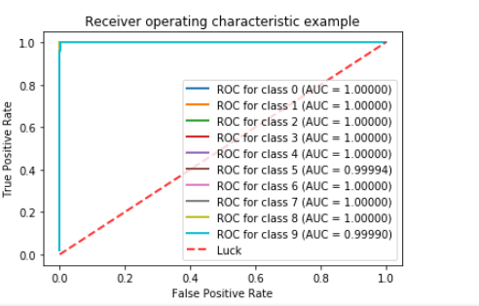

Gaussian Naive Base Classifier:

iter num : 1 of data split

best parameters : {}

confusion matrix :

[[44 1 0 0 1 0 0 0 0 0]

[ 0 40 1 0 0 0 0 0 3 0]

[ 0 8 20 7 0 0 0 0 10 0]

[ 0 0 0 43 0 0 0 1 3 1]

[ 0 6 0 0 30 1 0 2 1 0]

[ 0 0 0 1 0 36 0 3 1 0]

[ 0 0 1 0 0 0 46 0 0 0]

[ 0 0 0 0 1 0 0 46 0 0]

[ 0 10 0 2 0 2 0 1 28 0]

[ 0 2 0 5 0 1 1 7 3 30]]

Accuracy Measure : 0.806666666667

classification report :

precision recall f1-score support

0 1.00 0.96 0.98 46

1 0.60 0.91 0.72 44

2 0.91 0.44 0.60 45

3 0.74 0.90 0.81 48

4 0.94 0.75 0.83 40

5 0.90 0.88 0.89 41

6 0.98 0.98 0.98 47

7 0.77 0.98 0.86 47

8 0.57 0.65 0.61 43

9 0.97 0.61 0.75 49

avg / total 0.84 0.81 0.80 450

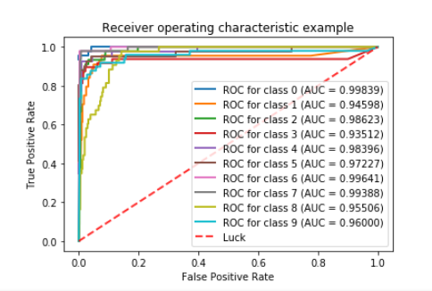

Logistic Regression Classifier:

iter num : 1 of data split

best parameters : {'fit_intercept': False, 'max_iter': 1000, 'penalty': 'l2', 'tol': 0.05}

confusion matrix :

[[45 0 0 0 1 0 0 0 0 0]

[ 0 40 1 0 1 0 0 0 2 0]

[ 0 0 45 0 0 0 0 0 0 0]

[ 0 0 1 46 0 0 0 0 1 0]

[ 0 1 0 0 38 0 0 0 1 0]

[ 0 0 0 0 0 41 0 0 0 0]

[ 0 0 0 0 0 0 47 0 0 0]

[ 0 0 0 1 0 0 0 46 0 0]

[ 0 2 1 1 0 0 0 0 39 0]

[ 0 0 0 0 0 2 0 0 3 44]]

Accuracy Measure : 0.957777777778

classification report :

precision recall f1-score support

0 1.00 0.98 0.99 46

1 0.93 0.91 0.92 44

2 0.94 1.00 0.97 45

3 0.96 0.96 0.96 48

4 0.95 0.95 0.95 40

5 0.95 1.00 0.98 41

6 1.00 1.00 1.00 47

7 1.00 0.98 0.99 47

8 0.85 0.91 0.88 43

9 1.00 0.90 0.95 49

avg / total 0.96 0.96 0.96 450

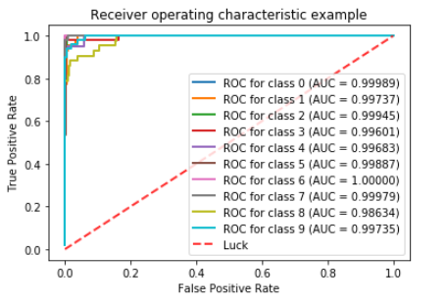

KNN Classifier:

iter num : 1 of data split

best parameters : {'algorithm': 'auto', 'n_neighbors': 3, 'p': 2, 'weights': 'distance'}

confusion matrix :

[[46 0 0 0 0 0 0 0 0 0]

[ 0 44 0 0 0 0 0 0 0 0]

[ 0 0 45 0 0 0 0 0 0 0]

[ 0 0 0 48 0 0 0 0 0 0]

[ 0 0 0 0 39 0 0 0 1 0]

[ 0 0 0 0 0 41 0 0 0 0]

[ 0 0 0 0 0 0 47 0 0 0]

[ 0 0 0 0 0 0 0 47 0 0]

[ 0 1 0 1 0 0 0 0 41 0]

[ 0 0 0 0 1 0 0 0 0 48]]

Accuracy Measure : 0.991111111111

classification report :

precision recall f1-score support

0 1.00 1.00 1.00 46

1 0.98 1.00 0.99 44

2 1.00 1.00 1.00 45

3 0.98 1.00 0.99 48

4 0.97 0.97 0.97 40

5 1.00 1.00 1.00 41

6 1.00 1.00 1.00 47

7 1.00 1.00 1.00 47

8 0.98 0.95 0.96 43

9 1.00 0.98 0.99 49

avg / total 0.99 0.99 0.99 450

